Help for sensors:

Sensors: the 2 necessary sensors for gmapping are a camera and a laser beam. The ones used in the model will come from the ros plugins wiki. However it is possible to integrate more sensors, like kinects, better beams. Another possibility is to tweek the sensors to make them better

http://gazebosim.org/tutorials?tut=ros_gzplugins

The plugins
they allow functionality and they are coded into the mybot.gazebo file
Commented code for camera plugin:

<!--for the camera and image adquisition-->
<gazebo reference="camera"><!--links to an object of the robot-->
<material>Gazebo/Green</material>
<sensor type="camera" name="camera1">
<update_rate>30.0</update_rate>
<camera name="head">
<horizontal_fov>1.3962634</horizontal_fov>
<!--type of image-->
<image>
<width>800</width>
<height>800</height>
<format>R8G8B8</format>
</image>
<clip>
<near>0.02</near>
<far>300</far>
</clip>
</camera>
<plugin name="camera_controller" filename="libgazebo_ros_camera.so">
<alwaysOn>true</alwaysOn>
<updateRate>0.0</updateRate>
<!--topic camera-->
<cameraName>mybot/camera1</cameraName>
<!--topic names (camera info and image)-->
<imageTopicName>image_raw</imageTopicName>
<cameraInfoTopicName>camera_info</cameraInfoTopicName>
<frameName>camera</frameName>
<hackBaseline>0.07</hackBaseline>
<distortionK1>0.0</distortionK1>
<distortionK2>0.0</distortionK2>
<distortionK3>0.0</distortionK3>
<distortionT1>0.0</distortionT1>
<distortionT2>0.0</distortionT2>
</plugin>
</sensor>
</gazebo>

Commented code for the laser plugin

<!--for the laser hokuyo -->
<gazebo reference="hokuyo"><!--links to an object of the robot-->
<sensor type="gpu_ray" name="head_hokuyo_sensor">
<pose>0 0 0 0 0 0</pose>
<!--if the laser is working it shows the plane-->
<visualize>true</visualize>
<!--frequency for the beam-->
<update_rate>40</update_rate>
<ray>
<scan>
<!--how we will scan-->
<horizontal>
<samples>720</samples>
<resolution>1</resolution>
<min_angle>-1.570796</min_angle>
<max_angle>1.570796</max_angle>
</horizontal>
</scan>
<!--how far does it go-->
<range>
<min>0.10</min>
<max>30.0</max>
<resolution>0.01</resolution>
</range>
<!--to improve results-->
<noise>
<type>gaussian</type>
<!-- Noise parameters based on published spec for Hokuyo laser
achieving "+-30mm" accuracy at range < 10m. A mean of 0.0m and
stddev of 0.01m will put 99.7% of samples within 0.03m of the true
reading. -->
<mean>0.0</mean>
<stddev>0.01</stddev>
</noise>
</ray>
<plugin name="gazebo_ros_head_hokuyo_controller" filename="libgazebo_ros_gpu_laser.so">
<!--topic to listen for-->
<topicName>/mybot/laser/scan</topicName>
<frameName>hokuyo</frameName>
</plugin>
</sensor>
</gazebo>

The visualization, joints, hitbox and physics
All of them are contained in the main urdf document that defines the robot mybot.xacro
The corresponding ones for the sensors are:

<!-- adding camera link and joint-->
<link name="camera">
<collision><!--hitbox-->
<origin xyz="0 0 0" rpy="0 0 0"/> <!--cartesian and angular coord to place camera-->
<geometry>
<box size="${cameraSize} ${cameraSize} ${cameraSize}"/>
</geometry>
</collision>
<visual><!--how is it gonna look (smaller than hitbox-->
<origin xyz="0 0 0" rpy="0 0 0"/>
<geometry>
<box size="${cameraSize} ${cameraSize} ${cameraSize}"/>
</geometry>
<material name="green"/><!--what color is gonna be-->
</visual>
<inertial><!--physics!!!!-->
<mass value="${cameraMass}"/>
<origin xyz="0 0 0" rpy="0 0 0"/>
<box_inertia m="${cameraMass}" x="${cameraSize}" y="${cameraSize}" z="${cameraSize}"/>
<inertia ixx="1e-6" ixy="0" ixz="0" iyy="1e-6" iyz="0" izz="1e-6"/>
</inertial>
</link>
<joint name="camera_joint" type="fixed">
<axis xyz="0 1 0"/>
<origin xyz=".2 0 0" rpy="0 0 0"/>
<parent link="chassis"/> <!--takes chasis as model-->
<child link="camera"/>
</joint>
<!--adding laser and the joint-->
<joint name="hokuyo_joint" type="fixed">
<axis xyz="0 1 0" />
<origin xyz=".15 0 .1" rpy="0 0 0"/>
<parent link="chassis"/>
<child link="hokuyo"/>
</joint>
<!-- Hokuyo Laser -->
<link name="hokuyo">
<collision>
<origin xyz="0 0 0" rpy="0 0 0"/>
<geometry>
<box size="0.1 0.1 0.1"/>
</geometry>
</collision>
<visual>
<origin xyz="0 0 0" rpy="0 0 0"/>
<geometry><!--for more complex geometries dae files with autocad-->
<mesh filename="package://mybot_description/meshes/hokuyo.dae"/>
</geometry>
</visual>
<inertial>
<mass value="1e-5" />
<origin xyz="0 0 0" rpy="0 0 0"/>
<inertia ixx="1e-6" ixy="0" ixz="0" iyy="1e-6" iyz="0" izz="1e-6" />
</inertial>
</link>

The results
In order to see the results the .sh files need to be ran. First the gazebo one and afterwards the rviz one. Rviz is a software that allows to quicly listen and visualize the topics of the robot

Check the laser beam:
1.-Run the gazebo simulator with the corresponding .sh
2.-Place some objects in the gazebo world, or precharge a map diretly in the xml
3.-If its working and the visualization is set to true in the plugins file you should see the beam getting cut by the objets

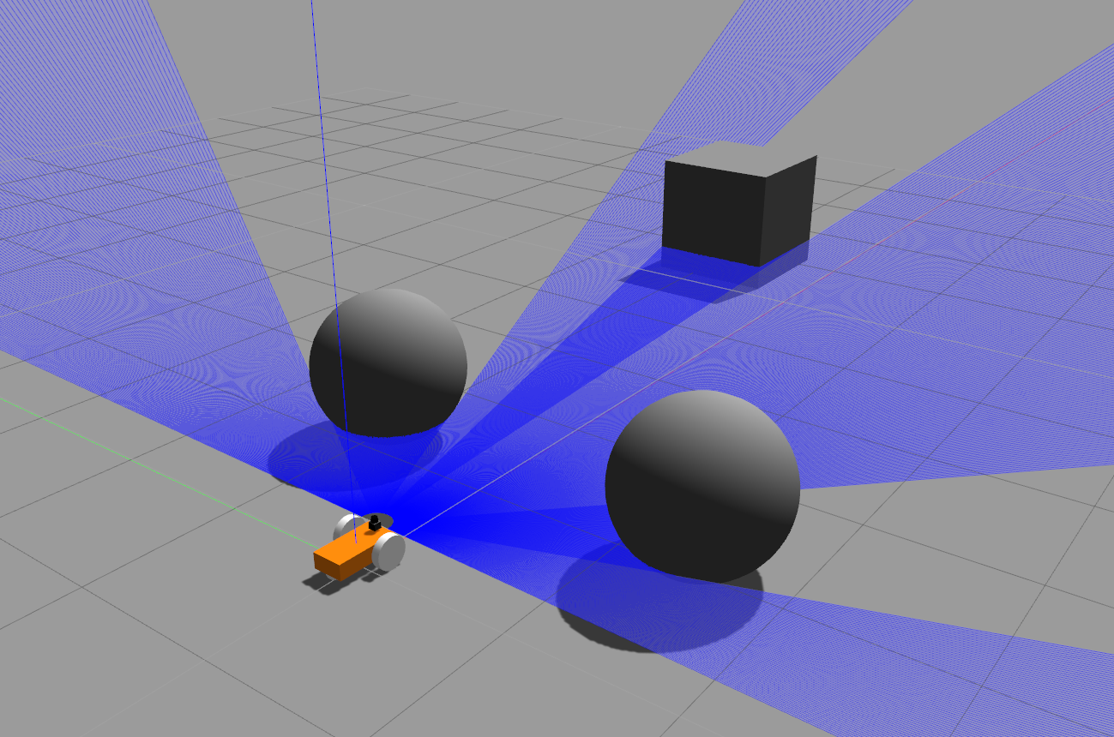

Check the camera
There are 2 possible ways of doing so:
Running the ros module to visualize pictures and telling it to listen to the topic which is assigned for the raw images of the camera

1.-rostopic list (to find the topic of the camera)
2.-rosrun image_view image_view image:=(found topic)

Using rviz
1.-run rviz with the .sh
2.-change the fixed frame to odom (or another if you defined differently in the urdf)
3.-press add and camera
4.-Press the arrow nexr to camera and connect to the topic, the image will be displayed

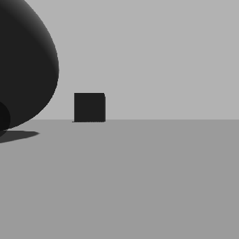

Finally rviz also makes it possible to see the laser beam if the user follows the same procedure as with the camera but instering a laser

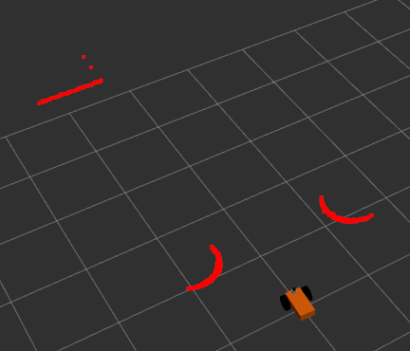

Why these sensors?

These sensors are the ones needed to generate the topics that afterwards ROS will use for gmapping

